**Experiment No.7**

**Aim:**  Edit/compile/run a program to read a string and display the total number of uppercase and lowercase letters.

**Program A:**

str="This Seal Of Shivaji, The Son Of Shahaji, Increasing In Size Like The Moon Of Pratipada (The First Day After The Moonless Night), It Will Be Worshiped By The World & It Will Shine Only For Well Being Of People."  
lower = 0  
upper = 0  
for i in str:  
 if (i.islower()):  
 lower+=1  
  
 elif(i.isupper()):  
 upper+=1  
print("The number of lowercase characters is: ", lower)  
print("The number of uppercase characters is: ",upper)

**Output:**

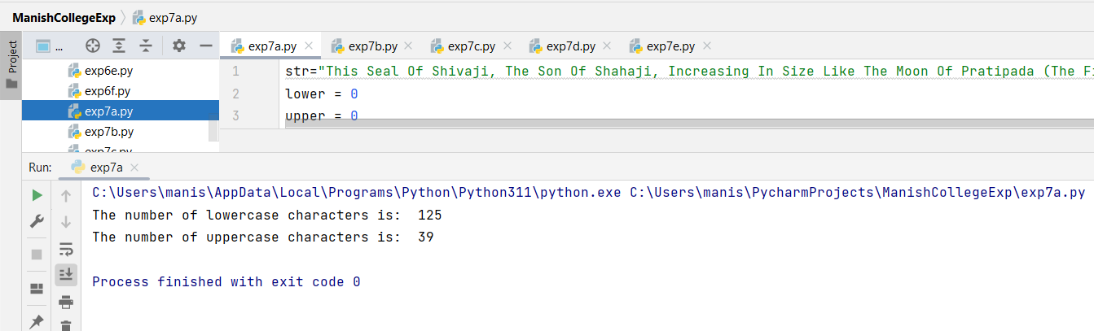

**Program B:**

def upplow(string):  
  
 upper = 0  
 lower = 0  
 for i in range(len(string)):  
 if(ord(string[i]) >=97 and  
 ord(string[i]) <=122):  
 lower+=1  
  
 elif(ord(string[i]) >=65 and  
 ord(string[i]) <=90):  
 upper+=1  
 print('Lower case characters = %s' %lower, "\n"  
 'Upper case characters = %s' %upper)  
  
string = "The Royal Seal of Shambho (Sambhaji), the son of Shiv (Shivaji) is shining with glory and is limitless as the sky. Under the shelter of this Rajmudra, everyone is protected. Nothing is superior to this Rajmudra."  
upplow(string)

**Output:**

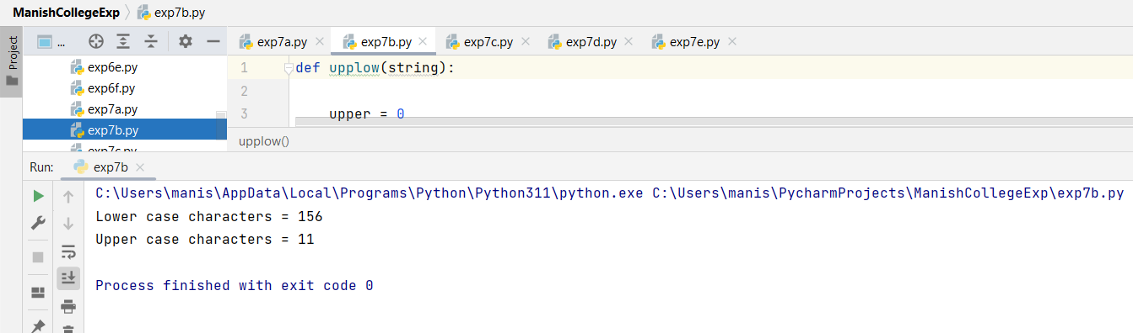

**Program C:**

s = "The Ram Mandir is a Hindu temple that is being built in Ayodhya, Uttar Pradesh, India, at the site of Ram Janmabhoomi, according to the Ramayana the birthplace of Rama, a principal deity of Hinduism. The temple construction is being supervised by the Shri Ram Janmabhoomi Teerth Kshetra."  
l,u = 0,0  
for i in s:  
 if(i >= 'a' and i <= 'z'):  
 l=l+1  
 if(i>'A' and i<='Z'):  
 u=u+1  
print('Lower case characters: ',l)  
print('Upper case characters: ',u)

**Output:**

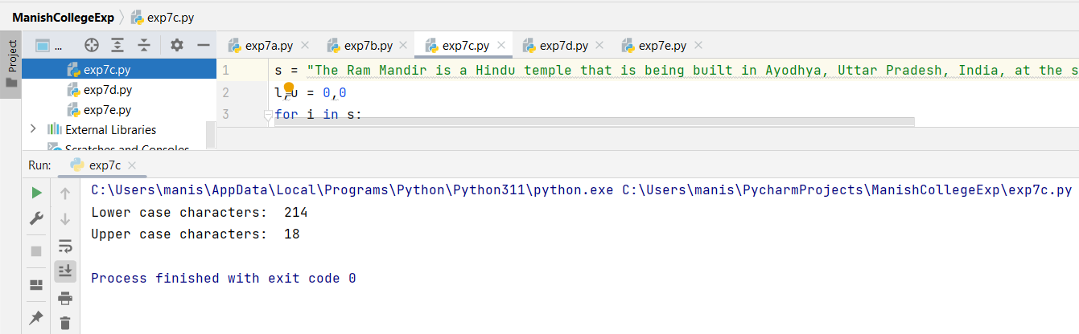

**Program D:**

string = "Appearing in its present form about 400 CE, the Mahabharata consists of a mass of mythological and didactic material arranged around a central heroic narrative that tells of the Struggle for Sovereignty between Two Groups of Cousins, The Kauravas (Sons of Dhritarashtra, The Descendant of Kuru) and The Pandavas (Sons of Pandu)."  
upper = 0  
lower = 0  
up = "ABCDEFGHIJKLMNOPQRSTUVWXYZ"  
lo = "abcdefghijklmnopqrstuvwxyz"  
for i in string:  
 if i in up:  
 upper+=1  
 elif i in lo:  
 lower+=1  
print('Lower case characters = %s' %lower)  
print('Upper case characters = %s' %upper)

**Output:**

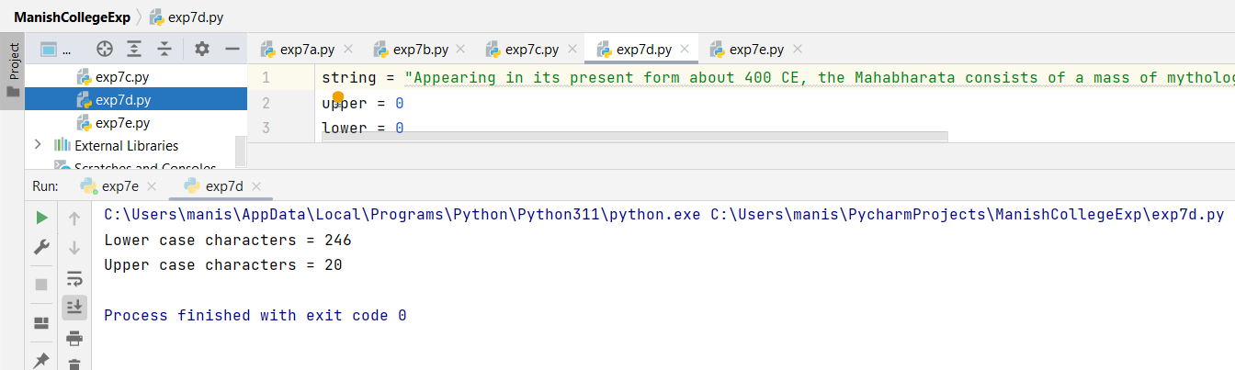

**Program E:**

string = input("Enter a string: ")  
uppercase = 0  
lowercase = 0  
for char in string:  
 if char.isupper():  
 uppercase += 1  
 elif char.islower():  
 lowercase += 1print("Total number of uppercase letters: ", uppercase)  
print("Total number of lowercase letters: ", lowercase)

**Output:**

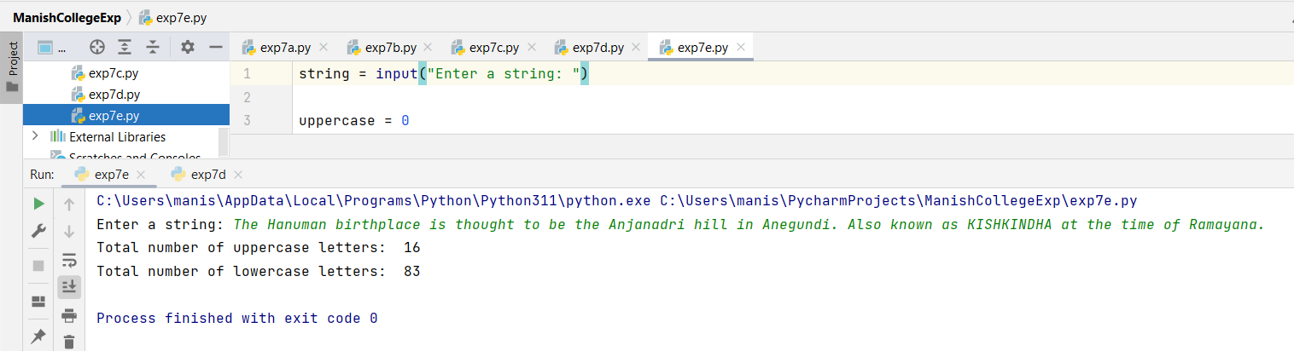

|  |  |  |  |
| --- | --- | --- | --- |
| **Practical Performance**  **(4)** | **Writeup & Oral**  **(4)** | **Attendance**  **(2)** | **Total**  **(10)** |
|  |  |  |  |